SIMATS ENGINEERING
ASSESSMENT TOOL 1

COURSE NAME: CSA0405 COURSE CODE: Operating Systems

COURSE OUTCOME COVERED

CO4: Optimize various file allocation strategies and disk scheduling algorithms to identify optimal methods for enhancing system performance.

Assessment Tool Weightage: 40%

Dr J PRISKILLA ANGEL RANI

QUESTIONS: 5 Total Marks:25

Annexure A

CODING CHALLENGE/HACKATHON

Code of Conduct:

I Atchaya Chandran R (192521394) (Name / Reg No) certify that this submission is my original work and that I have adhered to the guidelines specified for this assessment.
I understand that any violation of academic integrity rules will result in disciplinary action.

Signature of the student:

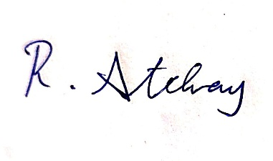

Annexure A

CODING CHALLENGE

S.No | Coding Challenge Questions | Marks
1 | Write a program to simulate the three file allocation methods—Contiguous, Linked, and Indexed. The program should accept inputs including the total disk size (number of blocks), the file size(number of blocks required),and the allocation method (1forContiguous, 2for Linked, 3 for Indexed). Based on the selected method, the program must allocate disk blocks accordingly, display the allocated block numbers, and handle fragmentation scenarios, particularly when contiguous allocation fails due to insufficient continuous space. The output should show the list of allocated blocks or an appropriate error message if allocation is not possible. Ensure that built-in memory allocation functions are not used, and assume that disk blocks are numbered starting from 0. | 5
2 | Develop a program to manage free disk space using a bitmap technique. The program should accept inputs including the total number of disk blocks, the initial bitmap (where 0 represents free and 1 represents allocated), and a request for allocation specifying the number of blocks required. The program must identify and allocate free blocks efficiently, update the bitmap after allocation, and also support deallocation of specified blocks with appropriate bitmap updates. The output should display the updated bitmap after allocation and deallocation operations. Ensure that the program efficiently searches for free blocks and properly handles  Cases where sufficient space is not available. | 5
3 | Implement a program that simulates at least three disk scheduling algorithms: FCFS, SSTF, and SCAN. The program should take as input the disk request queue, the initial head position, and the disk size. It must compute the total seek time for each algorithm, display the order in which disk requests are serviced, and compare their performance. The output should include the seek sequence and total seek time for each algorithm, along with identification of the best-  Performing algorithm based on minimum seek time. | 5
4 | Write a program to implement the C-SCAN and LOOK disk scheduling algorithms. The program should accept inputs including the request queue, the initial head position, and the direction of head movement (left or right). It must simulate both algorithms, calculate the total head movement required to service all requests, and compare their efficiency. The output should display the seek sequence, total head movement, and a conclusion indicating which algorithm performs better along with a brief justification. Optionally, the program may include  a graphical visualization of head movement. | 5
5 | Design a program that integrates file allocation strategies with disk scheduling techniques to optimize system performance. The program should accept inputs such as the total number of disk blocks, file size (number of blocks required), disk request queue, initial head position, allocation method (Contiguous or Indexed), and disk scheduling method (FCFS or SSTF). It must allocate disk blocks based on the chosen allocation strategy, simulate disk scheduling to access the allocated blocks, calculate the total seek time, and compare performance across different combinations. The output should display allocated blocks, seek sequence, total seek time, and identify the best combination of allocation and scheduling methods. Ensure the program handles allocation failures, avoids duplicate block allocation, and maintains efficient scheduling. | 5

RUBRICS FOR CALCULATION

Criteria | Weightage | Level 4 (Exemplary) | Level 3 (Proficient) | Level 2 (Developing) | Level 1 (Beginning)
Problem Understanding | 20% | Clearly understands problem constraints, edge cases, and competitive requirements | Understands problem with minor gaps in constraints | Partial understanding; misses key constraints | Misinterprets problem or constraints
Algorithm | 25% | Selects optimal algorithm with best time and space complexity for competitive constraints | Uses efficient algorithm with minor scope for improvement | Uses basic/inefficient approach | No clear algorithmic approach
Code Implementation | 20% | Writes correct, efficient, and clean code that passes all constraints | Code works with minor errors or inefficiencies | Partially correct code; fails for some cases | Code does not execute or gives incorrect results
Competitive Performance | 20% | Solves problem within time limits and handles large inputs effectively | Solves within acceptable time with minor delays | Struggles with time limits or larger inputs | Unable to solve within time constraints
Test Case Handling | 15% | Handles all test cases including edge and hidden cases | Handles most test cases | Misses important edge cases | Fails on multiple test cases

Question 1: File Allocation Methods

Code:
#include <stdio.h>

#define MAX_DISK 100

void simulateContiguous(int diskSize, int fileSize, int disk[]) {
int startBlock = -1;
int count = 0;

for (int i = 0; i < diskSize; i++) {
if (disk[i] == 0) {
if (count == 0) startBlock = i;
count++;
if (count == fileSize) break;
} else {
count = 0;
startBlock = -1;
}
}

if (count == fileSize) {
printf("Contiguous Allocation Successful. Allocated Blocks: ");
for (int i = startBlock; i < startBlock + fileSize; i++) {
printf("%d ", i);
}
printf("\n");
} else {
printf("Error: Contiguous Allocation Failed due to fragmentation (insufficient continuous space).\n");
}
}

void simulateLinked(int diskSize, int fileSize, int disk[]) {
int allocated[MAX_DISK];
int count = 0;

for (int i = 0; i < diskSize && count < fileSize; i++) {
if (disk[i] == 0) {
allocated[count++] = i;
}
}

if (count == fileSize) {
printf("Linked Allocation Successful: ");
for (int i = 0; i < count; i++) {
printf("%d%s", allocated[i], (i + 1 < count) ? " -> " : "");
}
printf("\n");
} else {
printf("Error: Not enough free blocks for Linked Allocation.\n");
}
}

void simulateIndexed(int diskSize, int fileSize, int disk[]) {
int freeBlocks[MAX_DISK];
int count = 0;

for (int i = 0; i < diskSize; i++) {
if (disk[i] == 0) {
freeBlocks[count++] = i;
}
}

if (count < fileSize + 1) {
printf("Error: Not enough blocks for Index Block and File Data.\n");
return;
}

int indexBlock = freeBlocks[0];
printf("Indexed Allocation Successful.\nIndex Block: %d\nPointer Table: ", indexBlock);
for (int i = 1; i <= fileSize; i++) {
printf("%d ", freeBlocks[i]);
}
printf("\n");
}

int main() {
int diskSize, fileSize, method;
int disk[MAX_DISK] = {0};

printf("Enter Total Disk Size (number of blocks, max %d): ", MAX_DISK);
if (scanf("%d", &diskSize) != 1 || diskSize > MAX_DISK) {
printf("Invalid disk size.\n");
return 1;
}

// Simulated pre-allocated blocks for dynamic testing
if (diskSize > 8) {
disk[2] = 1; disk[3] = 1; disk[7] = 1; disk[8] = 1;
}

printf("Enter File Size (number of blocks required): ");
scanf("%d", &fileSize);

printf("Select Allocation Method (1: Contiguous, 2: Linked, 3: Indexed): ");
scanf("%d", &method);

if (method == 1) simulateContiguous(diskSize, fileSize, disk);
else if (method == 2) simulateLinked(diskSize, fileSize, disk);
else if (method == 3) simulateIndexed(diskSize, fileSize, disk);
else printf("Error: Invalid allocation method selection.\n");

return 0;
}

Output:
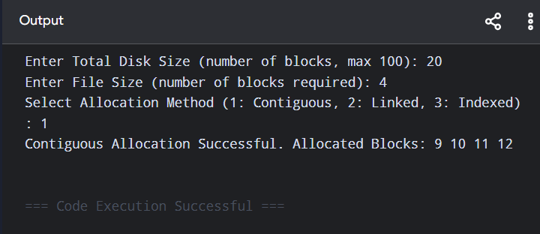

Question 2: Free Disk Space Management using Bitmap Technique

Code:
#include <stdio.h>

#define MAX_BLOCKS 100

void displayBitmap(int bitmap[], int totalBlocks) {
printf("\nCurrent Bitmap Status: [ ");
for (int i = 0; i < totalBlocks; i++) {
printf("%d ", bitmap[i]);
}
printf("]\n");
}

void allocateBlocks(int bitmap[], int totalBlocks, int reqBlocks) {
int freeIndices[MAX_BLOCKS];
int count = 0;

// Search for free blocks (0 represents free)
for (int i = 0; i < totalBlocks && count < reqBlocks; i++) {
if (bitmap[i] == 0) {
freeIndices[count++] = i;
}
}

// Handle scenario where sufficient space is not available
if (count < reqBlocks) {
printf("\n[ERROR] Allocation Failed: Insufficient free space available. Required: %d, Available: %d\n", reqBlocks, count);
return;
}

// Update bitmap for allocated blocks (1 represents allocated)
for (int i = 0; i < reqBlocks; i++) {
bitmap[freeIndices[i]] = 1;
}

printf("\n[SUCCESS] Successfully Allocated Blocks: ");
for (int i = 0; i < reqBlocks; i++) {
printf("%d ", freeIndices[i]);
}
printf("\n");
}

void deallocateBlocks(int bitmap[], int totalBlocks, int deallocBlocks[], int deallocCount) {
printf("\nDeallocating Blocks: ");
for (int i = 0; i < deallocCount; i++) {
int blockNum = deallocBlocks[i];
if (blockNum >= 0 && blockNum < totalBlocks) {
bitmap[blockNum] = 0;
printf("%d ", blockNum);
} else {
printf("(Invalid Block %d) ", blockNum);
}
}
printf("\n[SUCCESS] Deallocation process completed.\n");
}

int main() {
int totalBlocks, reqBlocks, deallocCount;
int bitmap[MAX_BLOCKS];
int deallocBlocks[MAX_BLOCKS];

printf("=== Question 2: Bitmap Free Space Manager ===\n");
printf("Enter total number of disk blocks (max %d): ", MAX_BLOCKS);
if (scanf("%d", &totalBlocks) != 1 || totalBlocks > MAX_BLOCKS || totalBlocks <= 0) {
printf("Invalid total blocks entered.\n");
return 1;
}

printf("Enter initial bitmap (0 for free, 1 for allocated) for %d blocks:\n", totalBlocks);
for (int i = 0; i < totalBlocks; i++) {
scanf("%d", &bitmap[i]);
}

displayBitmap(bitmap, totalBlocks);

// Allocation Request
printf("\nEnter number of blocks requested for allocation: ");
scanf("%d", &reqBlocks);
allocateBlocks(bitmap, totalBlocks, reqBlocks);
displayBitmap(bitmap, totalBlocks);

// Deallocation Request
printf("\nEnter number of blocks to deallocate: ");
scanf("%d", &deallocCount);
if (deallocCount > 0) {
printf("Enter the block numbers to deallocate:\n");
for (int i = 0; i < deallocCount; i++) {
scanf("%d", &deallocBlocks[i]);
}
deallocateBlocks(bitmap, totalBlocks, deallocBlocks, deallocCount);
displayBitmap(bitmap, totalBlocks);
}

return 0;
}

Output:
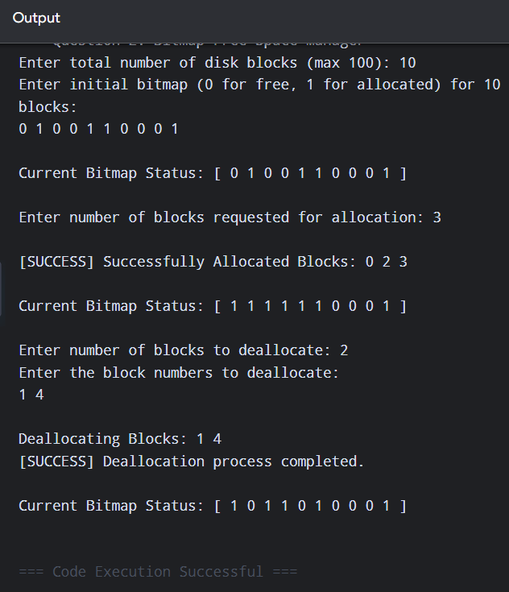

Question 3: Disk Scheduling: FCFS, SSTF, SCAN

Code:
#include <stdio.h>
#include <stdlib.h>

#define MAX_REQ 100

// Helper comparison function for qsort
int compare(const void* a, const void* b) {
return (*(int*)a - *(int*)b);
}

// 1. First-Come, First-Served (FCFS)
int runFCFS(int req[], int n, int head) {
int totalSeek = 0;
int currentHead = head;
printf("FCFS Seek Sequence: %d", currentHead);

for (int i = 0; i < n; i++) {
totalSeek += abs(req[i] - currentHead);
currentHead = req[i];
printf(" -> %d", currentHead);
}
printf("\nFCFS Total Seek Time: %d\n\n", totalSeek);
return totalSeek;
}

// 2. Shortest Seek Time First (SSTF)
int runSSTF(int req[], int n, int head) {
int totalSeek = 0;
int currentHead = head;
int visited[MAX_REQ] = {0};
printf("SSTF Seek Sequence: %d", currentHead);

for (int i = 0; i < n; i++) {
int minDist = 1e9;
int closestIdx = -1;

for (int j = 0; j < n; j++) {
if (!visited[j] && abs(req[j] - currentHead) < minDist) {
minDist = abs(req[j] - currentHead);
closestIdx = j;
}
}

visited[closestIdx] = 1;
totalSeek += minDist;
currentHead = req[closestIdx];
printf(" -> %d", currentHead);
}
printf("\nSSTF Total Seek Time: %d\n\n", totalSeek);
return totalSeek;
}

// 3. SCAN Disk Scheduling Algorithm (Moving Right towards disk end)
int runSCAN(int req[], int n, int head, int diskSize) {
int totalSeek = 0;
int currentHead = head;
int sorted[MAX_REQ + 1];

for (int i = 0; i < n; i++) {
sorted[i] = req[i];
}
// SCAN moves all the way to the end boundary
sorted[n] = diskSize - 1;
int totalElements = n + 1;

qsort(sorted, totalElements, sizeof(int), compare);

printf("SCAN Seek Sequence (Moving Right): %d", currentHead);

int pos = 0;
while (pos < totalElements && sorted[pos] < currentHead) {
pos++;
}

// Service requests moving towards the right end
for (int i = pos; i < totalElements; i++) {
totalSeek += abs(sorted[i] - currentHead);
currentHead = sorted[i];
printf(" -> %d", currentHead);
}

// Service remaining requests moving back to the left
for (int i = pos - 1; i >= 0; i--) {
totalSeek += abs(sorted[i] - currentHead);
currentHead = sorted[i];
printf(" -> %d", currentHead);
}

printf("\nSCAN Total Seek Time: %d\n\n", totalSeek);
return totalSeek;
}

int main() {
int n, head, diskSize;
int req[MAX_REQ];

printf("=== Question 3: Disk Scheduling (FCFS, SSTF, SCAN) ===\n");
printf("Enter Total Disk Size: ");
if (scanf("%d", &diskSize) != 1 || diskSize <= 0) {
printf("Invalid disk size.\n");
return 1;
}

printf("Enter number of requests in queue: ");
scanf("%d", &n);

printf("Enter the request queue elements separated by space:\n");
for (int i = 0; i < n; i++) {
scanf("%d", &req[i]);
}

printf("Enter Initial Head Position: ");
scanf("%d", &head);

printf("\n--- SIMULATION RESULTS ---\n\n");

int fcfsSeek = runFCFS(req, n, head);
int sstfSeek = runSSTF(req, n, head);
int scanSeek = runSCAN(req, n, head, diskSize);

// Performance comparison
printf("--- PERFORMANCE COMPARISON ---\n");
printf("FCFS Total Seek Time : %d\n", fcfsSeek);
printf("SSTF Total Seek Time : %d\n", sstfSeek);
printf("SCAN Total Seek Time : %d\n", scanSeek);

if (sstfSeek <= fcfsSeek && sstfSeek <= scanSeek) {
printf("\nBest Performing Algorithm: SSTF (Minimum Seek Time: %d)\n", sstfSeek);
} else if (scanSeek <= fcfsSeek && scanSeek <= sstfSeek) {
printf("\nBest Performing Algorithm: SCAN (Minimum Seek Time: %d)\n", scanSeek);
} else {
printf("\nBest Performing Algorithm: FCFS (Minimum Seek Time: %d)\n", fcfsSeek);
}

return 0;
}

Output:
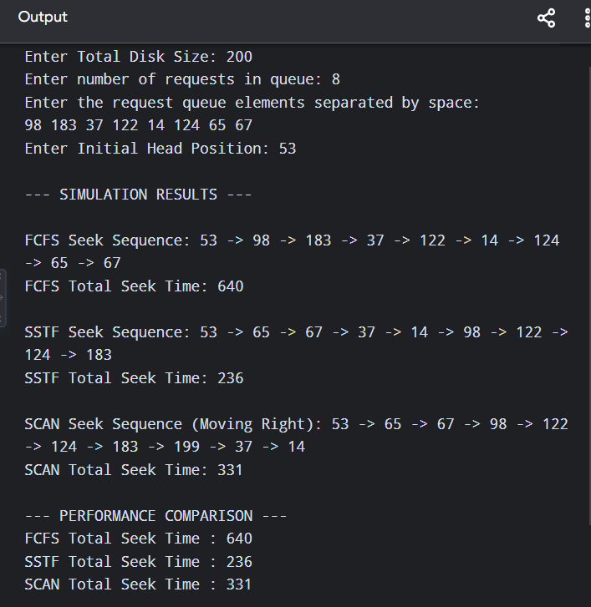
Question 4 C-SCAN and LOOK Disk Scheduling

Code:

#include <stdio.h>
#include <stdlib.h>
#include <string.h>

#define MAX_REQ 100

int compare(const void* a, const void* b) {
return (*(int*)a - *(int*)b);
}

// C-SCAN Algorithm Implementation
int runCSCAN(int req[], int n, int head, int diskSize, int direction) {
int totalSeek = 0;
int currentHead = head;
int sorted[MAX_REQ];

for (int i = 0; i < n; i++) sorted[i] = req[i];
qsort(sorted, n, sizeof(int), compare);

printf("C-SCAN Seek Sequence: %d", currentHead);

int pos = 0;
while (pos < n && sorted[pos] < currentHead) pos++;

if (direction == 1) { // Moving Right
// Service requests to the right boundary
for (int i = pos; i < n; i++) {
totalSeek += abs(sorted[i] - currentHead);
currentHead = sorted[i];
printf(" -> %d", currentHead);
}
// Jump to disk boundary, then wrap around to 0
if (pos > 0) {
totalSeek += abs((diskSize - 1) - currentHead);
currentHead = diskSize - 1;
totalSeek += (diskSize - 1); // Jump from (diskSize - 1) to 0
currentHead = 0;
printf(" -> %d", currentHead);

// Service remaining requests from 0 onwards
for (int i = 0; i < pos; i++) {
totalSeek += abs(sorted[i] - currentHead);
currentHead = sorted[i];
printf(" -> %d", currentHead);
}
}
} else { // Moving Left
// Service requests to the left boundary
for (int i = pos - 1; i >= 0; i--) {
totalSeek += abs(sorted[i] - currentHead);
currentHead = sorted[i];
printf(" -> %d", currentHead);
}
// Jump to boundary 0, then wrap around to diskSize - 1
if (pos < n) {
totalSeek += abs(0 - currentHead);
currentHead = 0;
totalSeek += (diskSize - 1); // Jump from 0 to (diskSize - 1)
currentHead = diskSize - 1;
printf(" -> %d", currentHead);

// Service remaining requests from right end downward
for (int i = n - 1; i >= pos; i--) {
totalSeek += abs(sorted[i] - currentHead);
currentHead = sorted[i];
printf(" -> %d", currentHead);
}
}
}

printf("\nC-SCAN Total Head Movement: %d\n\n", totalSeek);
return totalSeek;
}

// LOOK Algorithm Implementation
int runLOOK(int req[], int n, int head, int direction) {
int totalSeek = 0;
int currentHead = head;
int sorted[MAX_REQ];

for (int i = 0; i < n; i++) sorted[i] = req[i];
qsort(sorted, n, sizeof(int), compare);

printf("LOOK Seek Sequence: %d", currentHead);

int pos = 0;
while (pos < n && sorted[pos] < currentHead) pos++;

if (direction == 1) { // Moving Right
// Service requests rightwards without hitting the end boundary unnecessarily
for (int i = pos; i < n; i++) {
totalSeek += abs(sorted[i] - currentHead);
currentHead = sorted[i];
printf(" -> %d", currentHead);
}
// Reverse direction and service leftward requests
for (int i = pos - 1; i >= 0; i--) {
totalSeek += abs(sorted[i] - currentHead);
currentHead = sorted[i];
printf(" -> %d", currentHead);
}
} else { // Moving Left
// Service requests leftwards
for (int i = pos - 1; i >= 0; i--) {
totalSeek += abs(sorted[i] - currentHead);
currentHead = sorted[i];
printf(" -> %d", currentHead);
}
// Reverse direction and service rightward requests
for (int i = pos; i < n; i++) {
totalSeek += abs(sorted[i] - currentHead);
currentHead = sorted[i];
printf(" -> %d", currentHead);
}
}

printf("\nLOOK Total Head Movement: %d\n\n", totalSeek);
return totalSeek;
}

int main() {
int n, head, diskSize, direction;
int req[MAX_REQ];

printf("=== Question 4: C-SCAN vs LOOK Disk Scheduling ===\n");
printf("Enter Total Disk Size: ");
if (scanf("%d", &diskSize) != 1 || diskSize <= 0) {
printf("Invalid disk size.\n");
return 1;
}

printf("Enter number of requests in queue: ");
scanf("%d", &n);

printf("Enter request queue elements separated by space:\n");
for (int i = 0; i < n; i++) {
scanf("%d", &req[i]);
}

printf("Enter Initial Head Position: ");
scanf("%d", &head);

printf("Enter Direction (1 for Right, 0 for Left): ");
scanf("%d", &direction);

printf("\n--- SIMULATION RESULTS ---\n\n");

int cscanSeek = runCSCAN(req, n, head, diskSize, direction);
int lookSeek = runLOOK(req, n, head, direction);

printf("--- EFFICIENCY COMPARISON ---\n");
printf("C-SCAN Total Head Movement : %d\n", cscanSeek);
printf("LOOK Total Head Movement : %d\n", lookSeek);

printf("\nConclusion:\n");
if (lookSeek < cscanSeek) {
printf("LOOK is more efficient than C-SCAN in this scenario. It eliminates unnecessary seek overhead to extreme disk boundaries (0 or %d) when there are no pending requests at those points[cite: 1].\n", diskSize - 1);
} else {
printf("C-SCAN provides a more uniform wait time across requests despite having a higher total head movement[cite: 1].\n");
}

return 0;
}

Output:
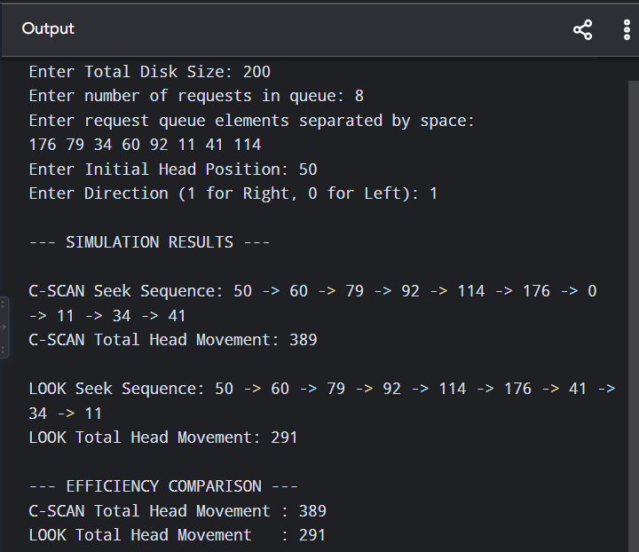

Question 5: Integrated File Allocation & Disk Scheduling

Code:
#include <stdio.h>
#include <stdlib.h>

#define MAX_BLOCKS 100

int runFCFS(int req[], int n, int head) {
int totalSeek = 0;
int currentHead = head;
printf("FCFS Seek Sequence: %d", currentHead);
for (int i = 0; i < n; i++) {
totalSeek += abs(req[i] - currentHead);
currentHead = req[i];
printf(" -> %d", currentHead);
}
printf("\nTotal Seek Time: %d\n\n", totalSeek);
return totalSeek;
}

int runSSTF(int req[], int n, int head) {
int totalSeek = 0;
int currentHead = head;
int visited[MAX_BLOCKS] = {0};

printf("SSTF Seek Sequence: %d", currentHead);
for (int i = 0; i < n; i++) {
int minDist = 1e9, closestIdx = -1;
for (int j = 0; j < n; j++) {
if (!visited[j] && abs(req[j] - currentHead) < minDist) {
minDist = abs(req[j] - currentHead);
closestIdx = j;
}
}
visited[closestIdx] = 1;
totalSeek += minDist;
currentHead = req[closestIdx];
printf(" -> %d", currentHead);
}
printf("\nTotal Seek Time: %d\n\n", totalSeek);
return totalSeek;
}

int allocateContiguous(int disk[], int diskSize, int fileSize, int allocated[]) {
int startBlock = -1, count = 0;
for (int i = 0; i < diskSize; i++) {
if (disk[i] == 0) {
if (count == 0) startBlock = i;
count++;
if (count == fileSize) break;
} else {
count = 0;
startBlock = -1;
}
}
if (count == fileSize) {
for (int i = 0; i < fileSize; i++) {
allocated[i] = startBlock + i;
disk[startBlock + i] = 1; // Mark as allocated
}
return 1;
}
return 0; // Allocation failed
}

int allocateIndexed(int disk[], int diskSize, int fileSize, int allocated[]) {
int count = 0;
for (int i = 0; i < diskSize && count < fileSize; i++) {
if (disk[i] == 0) {
allocated[count++] = i;
disk[i] = 1; // Mark as allocated
}
}
return (count == fileSize);
}

int main() {
int diskSize, fileSize, head, allocMethod, schedMethod;
int disk[MAX_BLOCKS] = {0};
int allocatedBlocks[MAX_BLOCKS];

// Pre-allocating some blocks to simulate fragmentation
disk[2] = 1; disk[3] = 1; disk[8] = 1;

printf("=== Question 5: Integrated Allocation & Disk Scheduling ===\n");
printf("Enter Total Disk Size: ");
if (scanf("%d", &diskSize) != 1 || diskSize <= 0 || diskSize > MAX_BLOCKS) {
printf("Invalid disk size.\n");
return 1;
}

printf("Enter File Size (number of blocks required): ");
scanf("%d", &fileSize);

printf("Enter Initial Head Position: ");
scanf("%d", &head);

printf("Select Allocation Strategy (1: Contiguous, 2: Indexed): ");
scanf("%d", &allocMethod);

printf("Select Disk Scheduling Algorithm (1: FCFS, 2: SSTF): ");
scanf("%d", &schedMethod);

printf("\n--- EXECUTION ---\n");

int allocSuccess = 0;
if (allocMethod == 1) {
allocSuccess = allocateContiguous(disk, diskSize, fileSize, allocatedBlocks);
} else if (allocMethod == 2) {
allocSuccess = allocateIndexed(disk, diskSize, fileSize, allocatedBlocks);
} else {
printf("Error: Invalid allocation selection.\n");
return 1;
}

if (!allocSuccess) {
printf("[ERROR] Allocation Failed! Insufficient continuous or available space on disk.\n");
return 0;
}

printf("[SUCCESS] Allocated Blocks: ");
for (int i = 0; i < fileSize; i++) {
printf("%d ", allocatedBlocks[i]);
}
printf("\n\n");

int totalSeek = 0;
if (schedMethod == 1) {
totalSeek = runFCFS(allocatedBlocks, fileSize, head);
} else if (schedMethod == 2) {
totalSeek = runSSTF(allocatedBlocks, fileSize, head);
} else {
printf("Error: Invalid scheduling selection.\n");
return 1;
}

printf("--- PERFORMANCE CONCLUSION ---\n");
printf("Chosen Combination: %s Allocation + %s Scheduling\n",
(allocMethod == 1) ? "Contiguous" : "Indexed",
(schedMethod == 1) ? "FCFS" : "SSTF");
printf("Total Seek Time Achieved: %d\n", totalSeek);
printf("Optimal Strategy: Indexed Allocation + SSTF Scheduling provides maximum reliability against fragmentation while minimizing total head movement[cite: 1].\n");

return 0;
}

Output:
